Harrison Central High School is a Title I school. Title I is part of the Every Student Succeeds Act (ESSA), and the purpose of this program is to ensure that all children have a fair, equal, and significant opportunity to obtain a high-quality education. The goal is for each student to reach, at a minimum, proficiency on challenging state academic achievement standards and state academic assessments. Also, Title I is a federally funded program that provides schools additional monies due to the percentage of students who receive free/reduced lunch.
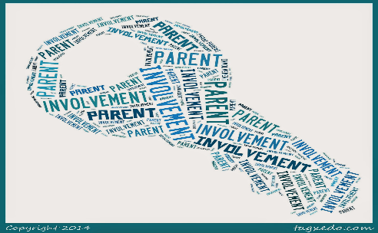

Under ESSA, Title I schools must provide the following information about teachers when asked:
- whether the teacher met state and certification requirements for the grade level and subject he/she is currently teaching
- whether the teacher received an emergency certificate through which state qualifications are waived
- whether the teacher is teaching in the field of discipline of the certification of the teacher
- whether the child is provided services by paraprofessionals and, if so, their qualifications
Parents/guardian are also encouraged to become involved in the school. Opportunities include using the Parent Portal of PowerSchool, virtually participating in Title I meetings, watching parent engagement videos, participating in surveys informing parents on how engagement funds should be spent, and communicating with teachers and administrators.
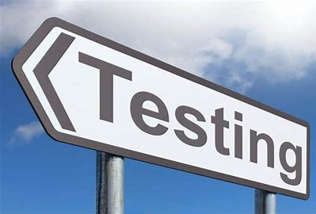

Title I schools must also give the following information about testing:
- subject matter assessed
- purpose of the assessment
- source of the requirement for the assessment
- amount of time it takes to complete the test, and schedule for the assessment (if available)
- time and format of disseminating results
.

Harrison Central High School’s School Wide Plan is to:
- increase proficiency in tested subjects
- increase communication among all stakeholders

- increase opportunities for teachers to receive targeted, individualized professional development
In order to achieve these goals, Harrison Central High School will be using title funds to:
- provide Instructional Literacy Coaches
- provide professional development for school staff

- provide extra time for student learning
- provide additional supplemental teaching materials

- provide supplemental technology equipment and supplies

